Table of Contents:
- Introduction
- Purpose
- Scope
- Functional Requirements
- Non-Functional Requirements
- Technological Requirements
- System Design and Architecture
- Future Enhancements
- Conclusion

1. Introduction
In the domain of Geographic Information Systems (GIS), data quality and clarity are essential for accurate spatial analysis, decision-making, and map-based visualization. One of the common issues in spatial datasets, especially in transportation planning, is the occurrence of overlapping line features such as bus routes. Overlaps may occur due to data redundancy, different data sources, or imprecise digitization. This issue hampers readability, analysis accuracy, and professional presentation of GIS layers.
This document presents a comprehensive Software Requirements Specification (SRS) for a QGIS-based geospatial tool that identifies and removes overlapping line segments within bus route datasets. Developed using the PyQGIS API, the tool enhances spatial data clarity by cleaning redundancies while preserving meaningful route information. The tool is implemented as a Python script designed for easy execution within the QGIS environment.
The report also demonstrates a work-in-progress prototype that showcases the core functionalities of the system, supported by annotated screenshots and sample outputs. This project is part of the IT3090.20 Software Development Team Project and has been carried out by students from the Universal of Higher Education (UHE).

2. Purpose
The primary purpose of this project is to develop a geospatial cleaning utility that eliminates overlapping segments from bus route line layers in QGIS. This tool aids transport planners, GIS analysts, and map designers in:
- Improving visual clarity and analytical accuracy of bus route maps.
- Automating the tedious manual process of identifying and editing overlaps.
- Preserving the integrity of route attributes while streamlining geometries.
By delivering clean, non-redundant spatial data, this tool contributes to more reliable route planning, optimized public transport designs, and clearer map-based reports for stakeholders.

3. Scope

The project focuses specifically on the cleaning and enhancement of line vector layers representing bus routes in QGIS. The following tasks fall within the system's scope:
- Identification of overlapping line segments.
- Removal of redundant overlaps using geometric subtraction.
- Outputting a cleaned version of the dataset with preserved attributes.
- Displaying both original and cleaned layers for user comparison.
In-Scope Functionalities:
- LineString and MultiLineString geometry handling.
- Execution within QGIS using PyQGIS scripting.
- Memory layer creation for non-destructive output.
Out of Scope Functionalities:
- Polygon or point geometries.
- Real-time GPS or routing data.
- Web map deployment or online storage.

4. Functional Requirements

- Polygon Layer Input
The system allows the user to load a polygon vector layer (e.g., shapefile or GeoPackage) into QGIS for processing.

- Overlap Detection
The system uses spatial indexing and geometry comparison to detect overlapping polygon features within the layer.
The number of overlaps is counted and displayed via the Python console.
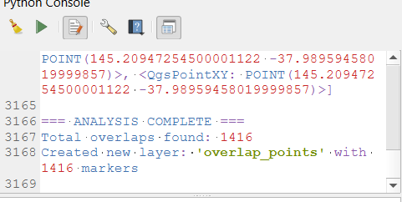

- Visual Marking of Overlaps
A new memory-based point layer is created to mark overlap locations using centroids or intersection points.
This layer is displayed on the QGIS canvas to allow users to visualize where overlaps occur.
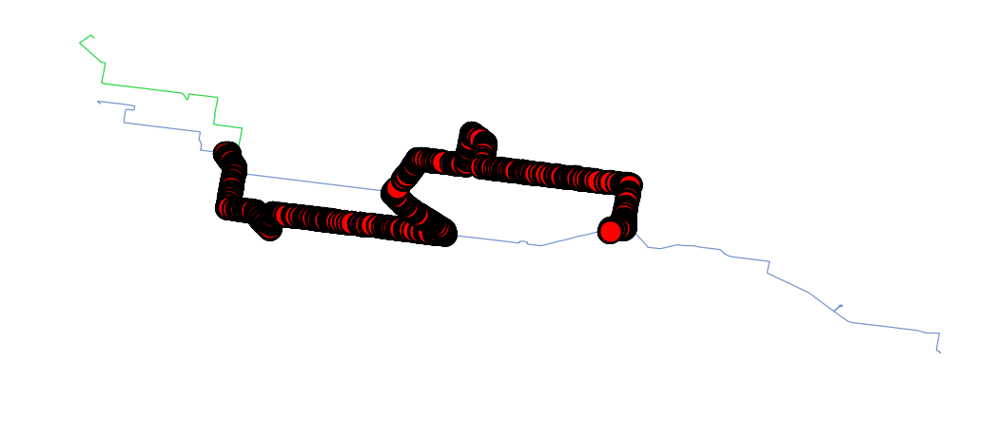
- Layer Duplication for Editing
A copy of the input layer is created before any removal operation is applied, ensuring the original dataset remains unchanged.
Appling removal of overall lapping:

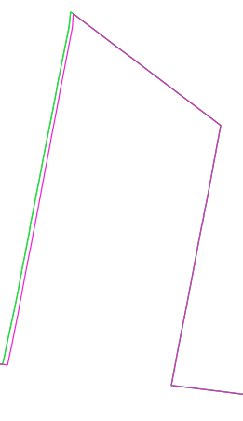
- Removal of Overlapping Features
The script removes one or more of the overlapping polygons based on conditions (e.g., feature ID or area).
The resulting layer contains cleaned geometries free from overlap.
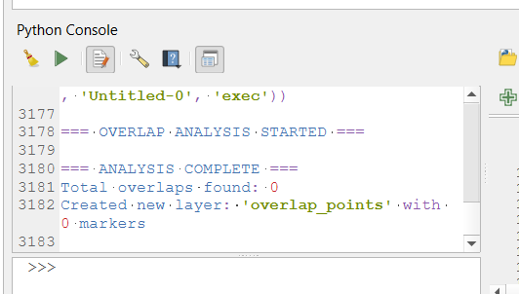

- Output and Visualization
Both the overlap-marking point layer and the cleaned polygon layer are added to the QGIS project.
Users can visually compare the “before” and “after” states to confirm success.

5. Non-Functional Requirements

- Quality
The system must detect all valid overlapping polygons with a high level of spatial accuracy.
The results are visually validated using map layers before and after processing.
Ensures only true geometric overlaps are removed.

- Maintainability
The script is written in modular PyQGIS code, following best practices for naming and comments.
Modular code with clear comments and function definitions.
It is easy to update, extend, or reuse for different datasets or geometries.

- Security
The tool performs all operations locally within the QGIS environment.
No external API calls or data transfers are made, ensuring data privacy and control.

- Usability
The script provides visual output through QGIS layers, making it understandable even without a GUI.
Users with basic QGIS knowledge can run the tool and interpret its results.
Screenshot comparisons allow users to verify processing without reading code output.
- Compatibility
Fully compatible with QGIS 3.x and major GIS file formats (.shp, .gpkg, .geojson).
The tool runs on any operating system supported by QGIS (Windows, Linux, macOS)

Technological Requirements

6.1 Software Requirements
- QGIS 3.28 or later
- Python 3.x
- PyQGIS (bundled with QGIS)

6.2 Hardware Requirements
- Minimum: Dual-core CPU, 4 GB RAM, 500 MB disk space
- Recommended: Quad-core CPU, 8 GB RAM, SSD for large datasets

7. System Design and Architecture
The system is designed as a linear pipeline where each stage prepares data for the next. This design ensures clarity and makes debugging easier. The architecture is modular, facilitating extension or modification for future requirements.
Design Phases Explained:
- Input Layer Validation: Checks if the selected layer contains valid LineString or MultiLineString geometries. This prevents invalid inputs from entering the pipeline.
- Geometry Collection: All geometries from the input layer are extracted and stored in memory. This facilitates multiple comparisons during the overlap removal loop.
- Overlap Looping: Each feature is compared with all others (except itself) to detect intersections. This nested loop ensures that all potential overlaps are considered.
- Intersection Calculation: Spatial operations are applied using PyQGIS methods. If a valid intersection is found, the shared geometry is isolated.
- Geometry Difference: The overlap is subtracted using the difference() method. This ensures only unique parts of the route remain.
- New Feature Creation: If the resulting geometry is still valid and non-empty, a new QgsFeature is created and appended to the cleaned memory layer.
- Canvas Update: Once all features are processed, the memory layer is added to the current QGIS project and the map canvas automatically adjusts to its extent.
This structure is encapsulated in a single main function, remove_overlaps(), with auxiliary logic blocks handling validation, geometry processing, and user feedback. Such separation aids in testing individual components and promotes code reuse.

8. Future Enhancements
To improve functionality, user experience, and robustness, the following enhancements are envisioned:
- Graphical User Interface (GUI): Introduce a user-friendly dialog box that allows selection of input layer, output name, and parameters like snapping tolerance or processing extent. This makes the tool accessible to non-technical users.
- Batch Processing Capability: Enable the tool to process multiple route layers in a single run. This would streamline workflows in transport agencies or urban planning departments that manage numerous datasets.
- Geometry Snapping: Add a pre-processing stage where near-duplicate geometries are snapped together within a specified tolerance. This will ensure that minor discrepancies in digitization don’t prevent overlaps from being identified.
- Undo/Redo Functionality: Implement a mechanism to backup original layers or changes. This could use QGIS’s native undo stack or generate backup layers, allowing users to revert changes if needed.
- Topology Rules Integration: Introduce support for user-defined topology rules to maintain geometric consistency across layers. This might include enforcing non-overlapping constraints or ensuring endpoint connectivity.
- Plugin Version: Convert the script into a full QGIS plugin for easier distribution, updates, and interface consistency. This would allow integration with QGIS Plugin Manager and make installation effortless.
- Logging and Reporting: Add detailed reporting features that summarize the overlaps detected, features affected, and spatial statistics of cleaned segments. Exporting these logs as CSV or PDF will aid in documentation.

Conclusion
The Bus Route Overlap Remover tool offers a robust and practical solution to a persistent challenge in Geographic Information Systems—overlapping features within bus route layers. Developed using the PyQGIS API and fully integrated into the QGIS desktop environment, the tool excels in both functionality and usability. Its primary strength lies in its ability to streamline and automate the detection and removal of redundant line segments, which not only improves map readability but also enhances the overall quality and reliability of spatial datasets used in transportation planning. By preserving attribute integrity throughout the cleaning process, the tool ensures that no critical data is lost during geometry operations, making it suitable for professional GIS workflows. Its intuitive usage via the Python Console makes it accessible for both students and analysts, while its offline capability protects user data and promotes independence from external systems. Non-functional qualities such as high processing speed, modular design, and maintainability contribute to its value as a scalable and adaptable tool. The tool’s educational potential also makes it highly effective for classroom demonstrations and academic exercises, where students can learn practical spatial data handling and scripting skills. Looking ahead, the script’s architecture readily supports future enhancements, including a graphical user interface (GUI), batch processing capabilities, geometry snapping, topology rule integration, and eventually a full-featured QGIS plugin. These advancements would significantly broaden its functionality and accessibility for a wider range of GIS users. In summary, the Bus Route Overlap Remover stands as a dependable, efficient, and accessible GIS utility that meaningfully bridges the gap between manual data editing and automated spatial data processing, ultimately contributing to cleaner, more accurate, and more actionable geographic information.

